**Project Title1:**  
***WeatherSim-Weather Detector***

**Submitted By:**  
Jessica John Osta

**Roll Number:**  
2460376

**College Email ID:**  
[jessica.john@btech.christuniversity.in](mailto:jessica.john@btech.christuniversity.in)

**Project Title 2 :**

***Music playlist organizer***

**Submitted By:**  
Anindita Saha

**Roll Number:**  
2460328

**College Email ID:**  
[anindita.saha@btech.christuniversity.in](mailto:anindita.saha@btech.christuniversity.in)

**Date of Submission:**  
26 September, 2025

**Course:**  
UI/UX Design Fundamentals

**Instructor Name:**  
Nagaveena

**Institution:**  
CHRIST (Deemed to be University)

**Date of Submission:**  
26 September, 2025

**1. Abstract**

The *WeatherSim* project is a responsive, interactive web-based weather dashboard designed to provide real-time weather data, forecasts, and visual analytics. The application integrates APIs, data visualization tools, and geolocation services to deliver an engaging and user-friendly experience. Core functionalities include live weather reports, 5-day forecasts, UV index, wind speed analysis, and downloadable weather reports in PDF format.

## ****2.Objectives****

* To design a modern, responsive weather dashboard with intuitive UI.
* To fetch and display real-time weather updates from APIs.
* To provide interactive data visualization using charts.
* To implement secure login and sign-up for user access.
* To generate downloadable weather reports for offline usage.

**3. Scope of the Project**

The project demonstrates practical implementation of **front-end development** using **HTML5, CSS3, and JavaScript**, with integration of external APIs for weather data. It is primarily aimed at students, developers, and weather enthusiasts who need a simplified and visually appealing weather information system.

**4. Tools & Technologies Use**

* **Frontend**: HTML5, CSS3, JavaScript (ES6+), Bootstrap 5
* **Data Visualization**: Chart.js
* **Mapping**: Leaflet.js
* **Authentication**: LocalStorage-based login/signup system
* **Report Generation**: jsPDF
* **External APIs**: OpenWeather API

## ****5. HTML Structure Overview****

* <header> → Navigation bar with logo and search bar.
* <main> → Sections for hero, weather display, map, charts, and forecast cards.
* <div> → Auth overlay for login/signup functionality.
* <footer> → Simple footer with app name and year.

## ****6. CSS Styling Strategy****

* **Glassmorphism overlay** for login/signup.
* **Responsive grid and flexbox** for layout organization.
* **Background switching** depending on weather condition (sunny, rainy, cloudy, etc.).
* **Animations** for fade-in/out during section transitions.
* **Consistent theme** with Google Fonts (Poppins) for clean typography.

## ****7. Key Features****

1. **Real-time Weather Fetching** via OpenWeather API.
2. **Interactive Charts** for temperature, humidity, and wind trends.
3. **Leaflet Map Integration** to locate searched cities.
4. **User Authentication** (signup/signin with validation).
5. **Downloadable PDF Report** of weather data.
6. **Dynamic Background & Icons** based on conditions.

## ****8. Challenges Faced & Solutions****

| * **Challenge:** Handling inconsistent API responses. **Solution:** Implemented fallbacks with mock data and error handling. | * **Challenge:** Handling inconsistent API responses. **Solution:** Implemented fallbacks with mock data and error handling. |
| --- | --- |
| * **Challenge:** Making the design mobile-friendly. **Solution:** Used Bootstrap grid and custom CSS media queries. | * **Challenge:** Making the design mobile-friendly. **Solution:** Used Bootstrap grid and custom CSS media queries. |
| * **Challenge:** Authentication without a backend. **Solution:** Used localStorage to manage user credentials securely. | * **Challenge:** Authentication without a backend. **Solution:** Used localStorage to manage user credentials securely. |
| * Challenge: Handling inconsistent API responses. Solution: Implemented fallbacks with mock data and error handling. | * **Challenge:** Handling inconsistent API responses. **Solution:** Implemented fallbacks with mock data and error handling. |

## 9. Outcome

* The project successfully delivers a **functional and aesthetic weather application** with a secure login system, accurate forecasts, and interactive visualizations. It combines practical coding knowledge with real-world use cases..

## ****10. Future Enhancements****

* Integration of **AI-powered weather predictions**.
* Adding **voice search functionality**.
* Implementing **multi-language support**.
* Storing user preferences on a **cloud database** instead of localStorage.
* Adding **severe weather alerts and notifications**.

**11. Sample Code**

function signupUser(username, password) {

if(localStorage.getItem(username)) {

alert("User already exists!");

} else {

localStorage.setItem(username, password);

alert("Signup successful! Please log in.");

}

}   
Authentication Logic (unique feature – no backend, only localStorage):  
  
HTML for the Featured Video Section

The featured-post section uses a video tag with autoplay, muted, and loop attributes to create a seamless, non-intrusive background video effect.

HTML

<section class="featured-post">

<video autoplay muted loop playsinline class="bg-video">

<source src="images/posts/featured-video.mp4" type="video/mp4">

Your browser does not support the video tag.

</video>

<div class="featured-content">

<h1>Exploring the Hidden Beaches of Bali</h1>

<p>Join me as I uncover Bali’s serene and untouched beaches, away from the bustling tourist spots...</p>

<a href="#" class="read-more">Read More</a>

</div>

</section>  
  
**Dynamic Background Change (unique UI effect):**  
function updateBackground(condition) {

document.body.style.backgroundImage =

`url('images/${getBackgroundFile(condition)}')`;

}

**PDF Report Download (unique reporting feature):**

function downloadReport(weatherData) {

const { jsPDF } = window.jspdf;

const doc = new jsPDF();

doc.text(`Weather Report for ${weatherData.name}`, 20, 20);

doc.text(`Temperature: ${weatherData.main.temp} °C`, 20, 40);

doc.save("WeatherReport.pdf");

}

**12. Screenshots of the webpages**

**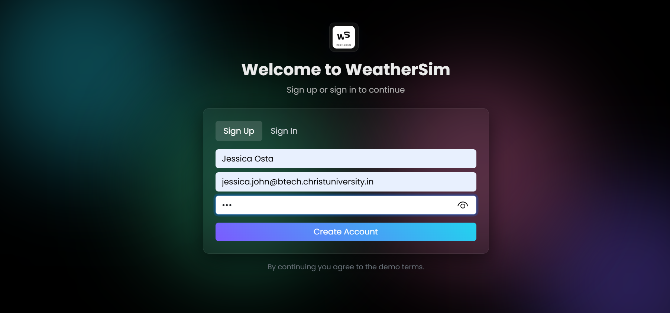  
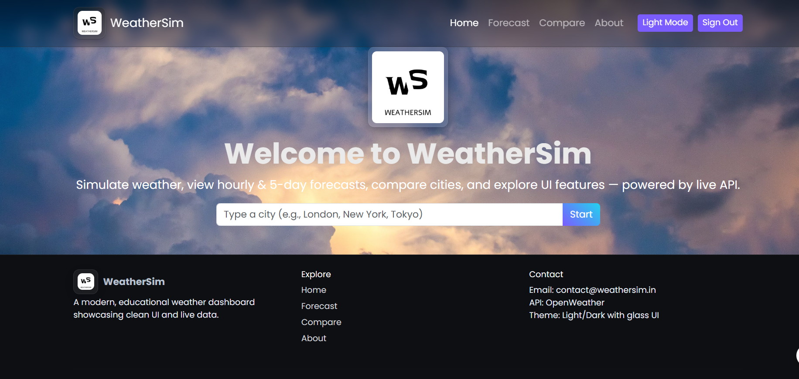  
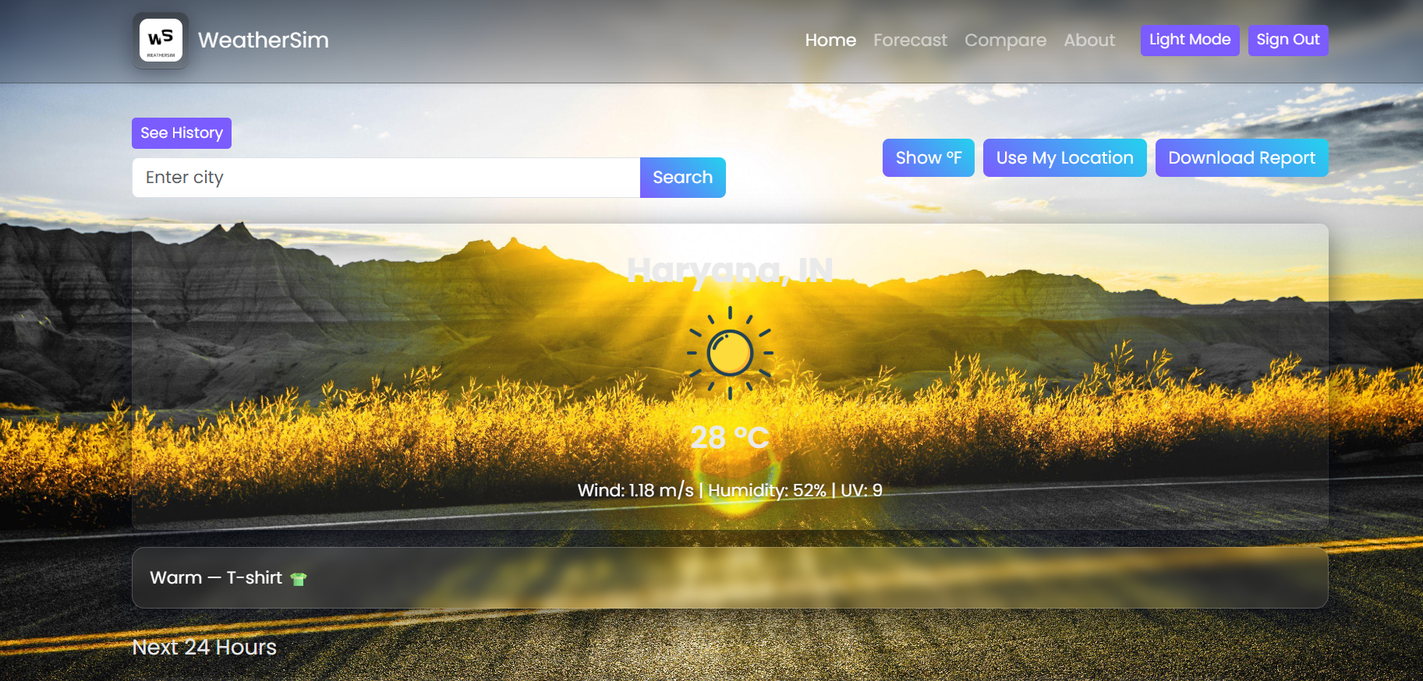  
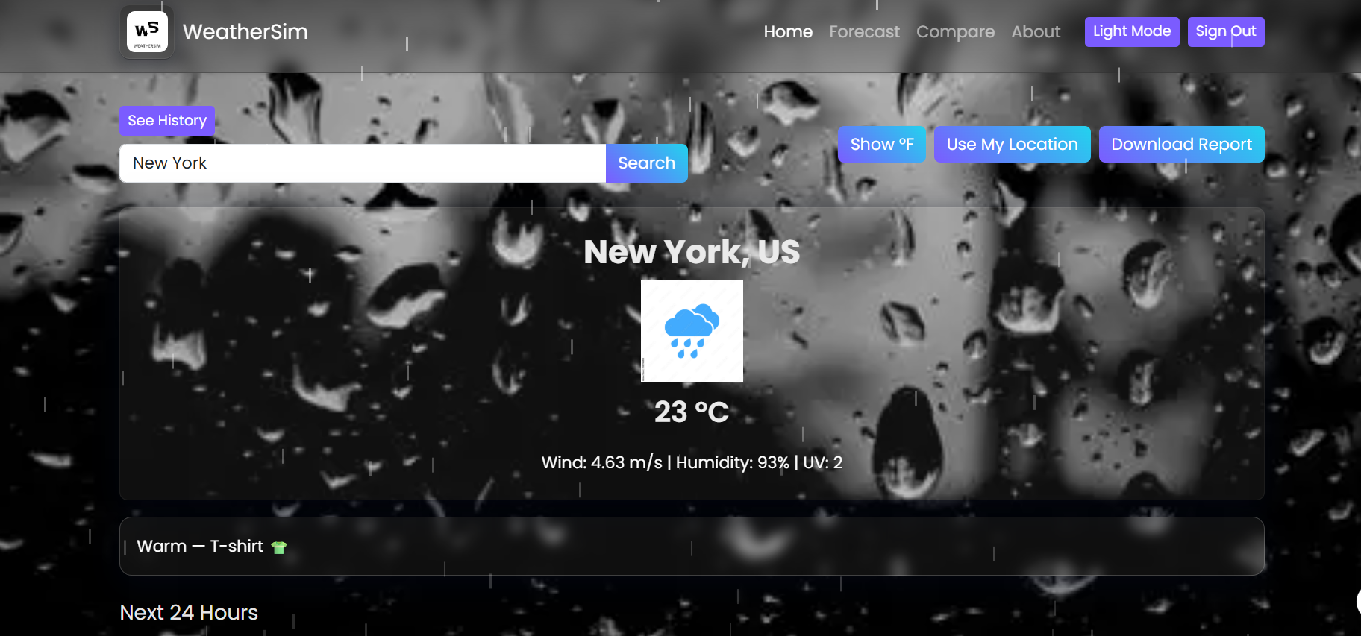**

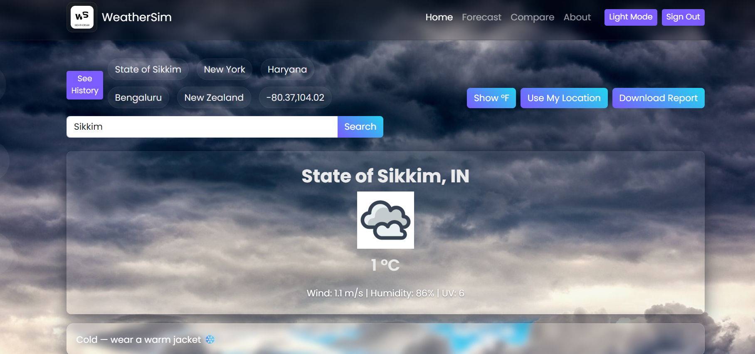

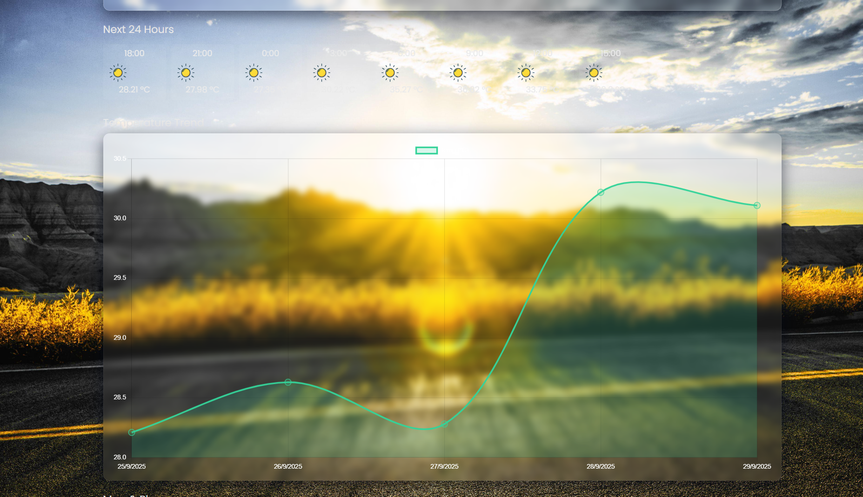

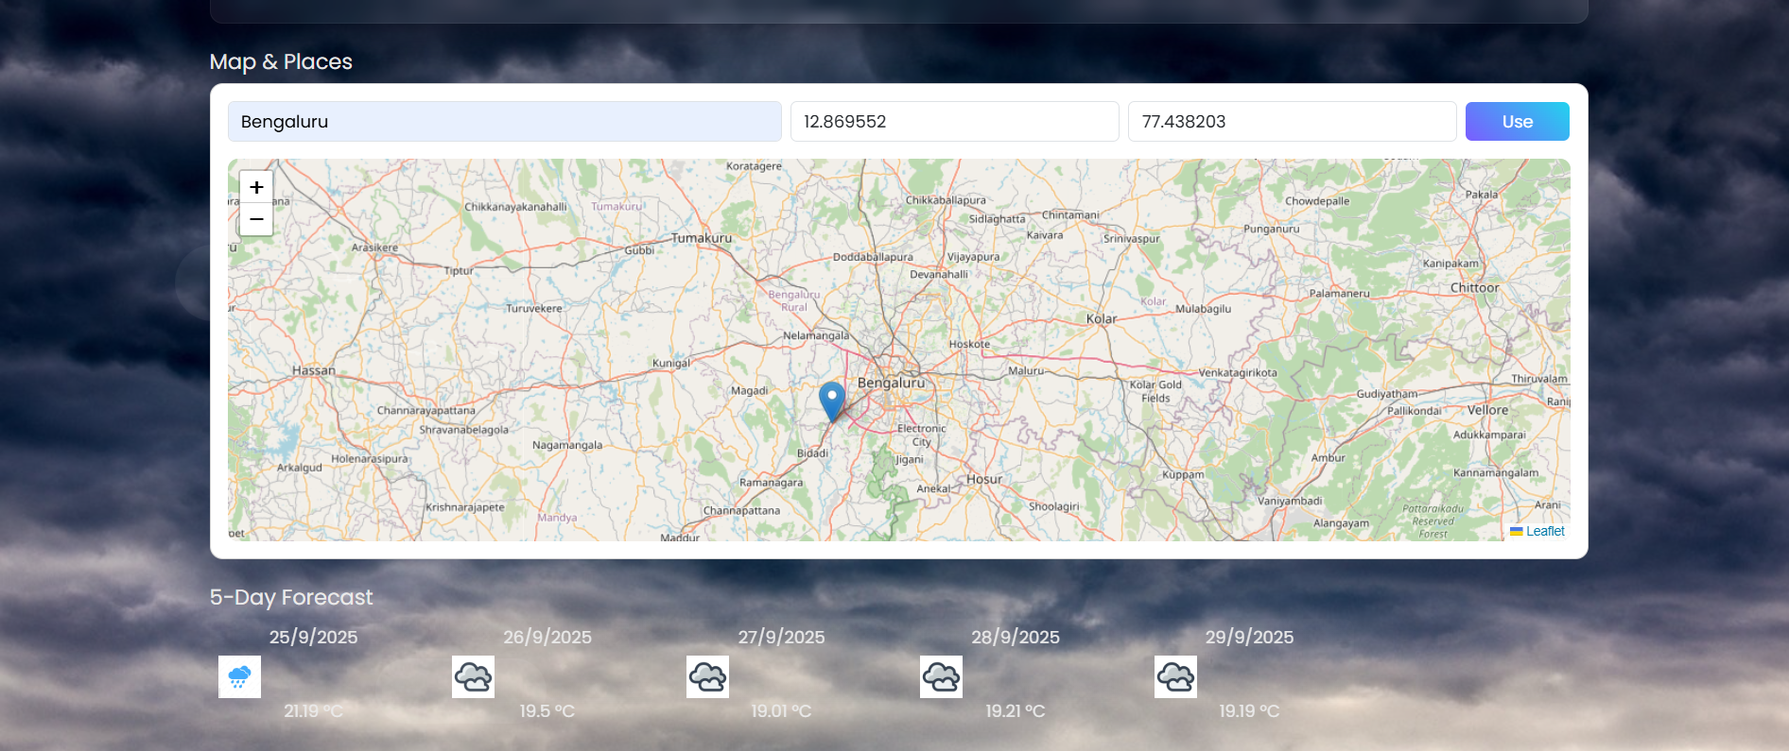

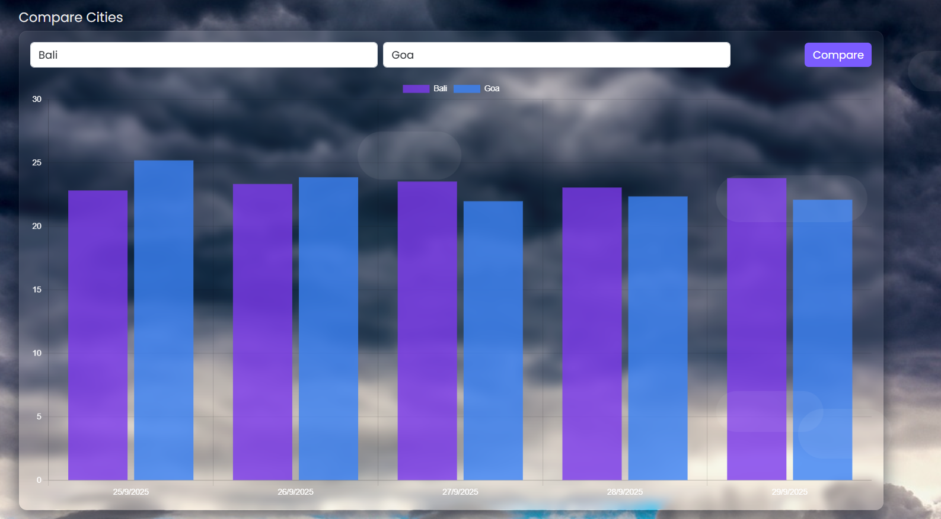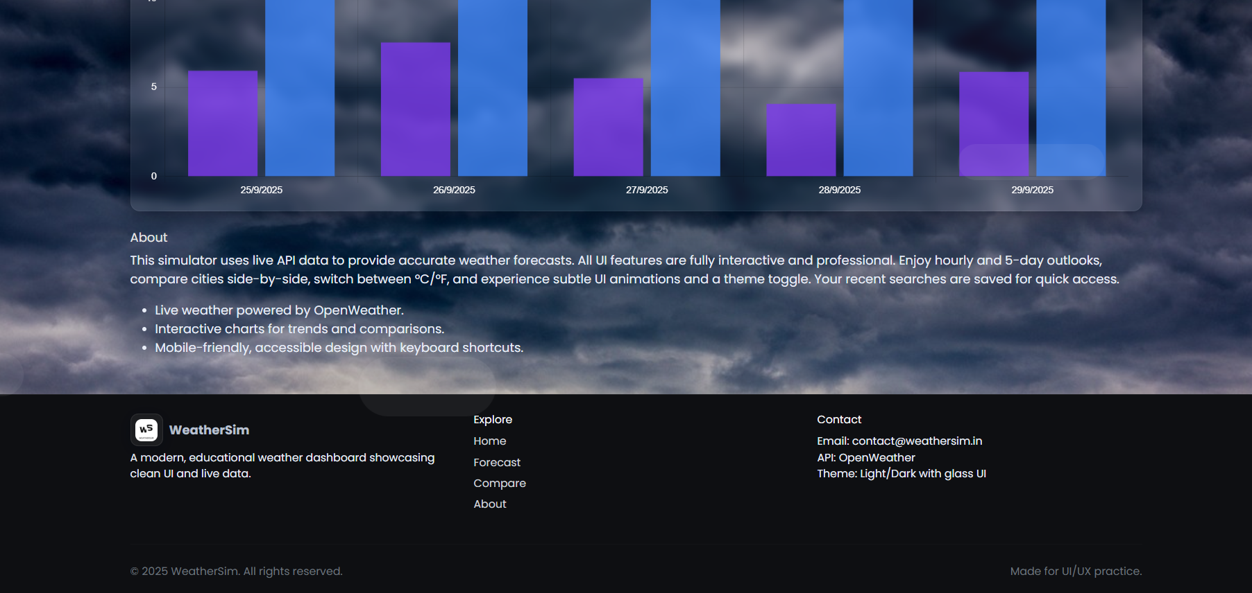

## ****14. Conclusion****

## The *WeatherSim* project demonstrates the integration of web technologies with real-world APIs to build a highly interactive and user-friendly application. It showcases the importance of frontend development skills, API handling, and data visualization. The project can be expanded further with AI, cloud integration, and enhanced interactivity to serve as a professional-grade weather solution.

## ****15. References**** • L&T LMS : https://learn.lntedutech.com/Landing/MyCourse